**Sprint 4**

In sprint 4 food analyzer feature is added using clarifiy food detection model and Nutrition by API-Ninjas API to get nutrition value for respective items

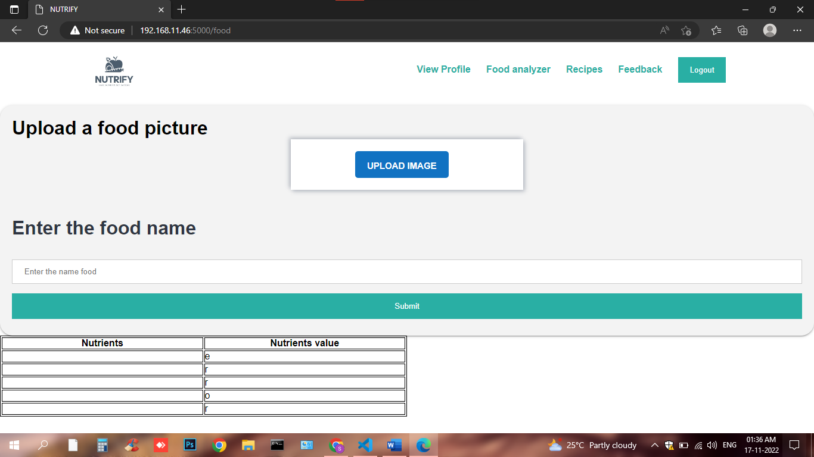

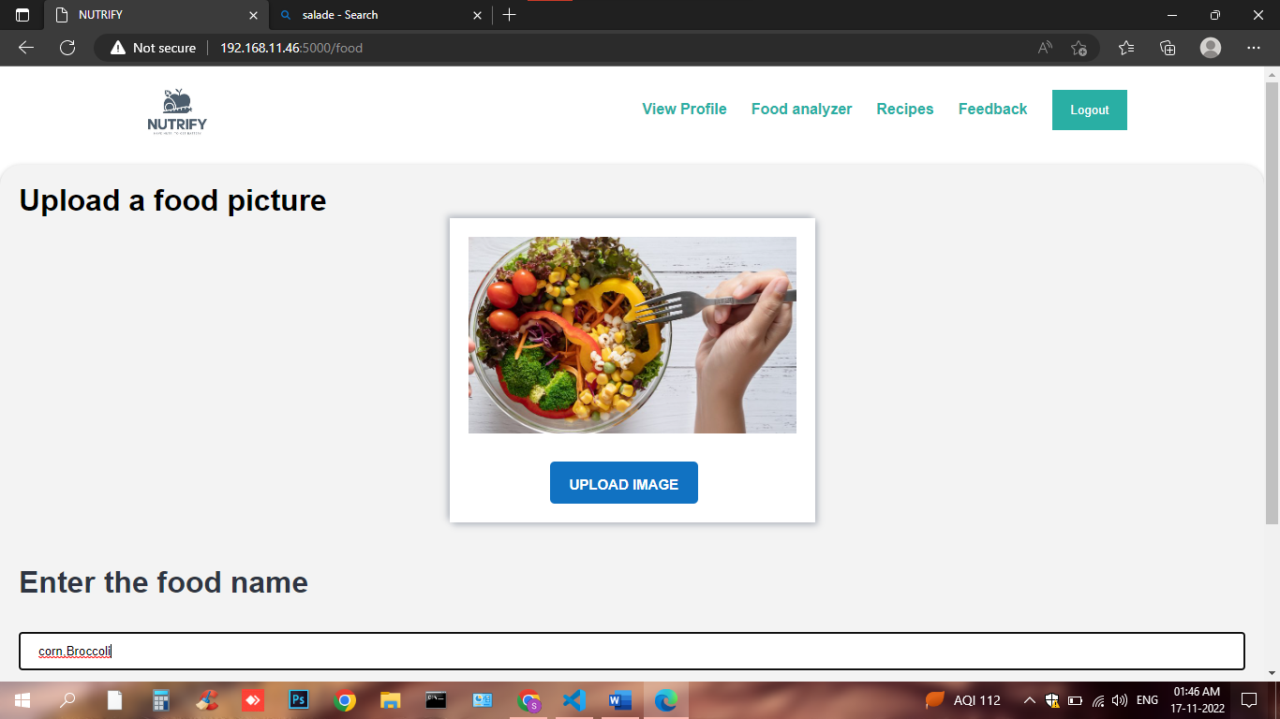

**The values are shown in form a table**

